Usability Test of
www.TowerRecords.com

August 2001 (editorial changes in August 2005 and December 2010)

Written by DialogDesign ved Rolf Molich, Skovkrogen 3, 3660 Stenløse, Denmark

Executive Summary
This report documents the findings of a usability test of the website www.TowerRecords.com carried out in May 2001 by DialogDesign. The main purpose of the test was to assess the usability of the current website for Northern European users.
Positive aspects about www.TowerRecords.com:
- Checkout-process. Test participants considered the checkout process smooth and convenient.
- Covers and music samples. All test participants commented positively on the fact that they could see covers and listen to music samples while selecting the goods they wanted to buy.
- Tolerant search. Several test participants mistyped the name of an artist or an album. The search facility accepted their input, quietly corrected the misprint and produced the correct result. In some instances the test participants never even noticed that they had made a mistake.
Improvement areas for www.TowerRecords.com:
- Quality assurance. Links to empty pages and database errors such as misspelled names of artists prevented several test participants from finding a desired product, even though it was available on the website. Quality assurance is important because such problems break down customers’ trust in the website.
- Unusable search results. Five of the six test participants gave up finding products either because a search result list contained nothing that resembled what they were looking for or because they were presented with detailed information about products at a too early stage. As a result they decided not to buy anything on www.TowerRecords.com even though we offered to pay for their purchase.
- More support for inexperienced music store shoppers. Three of the test participants felt that the site lacked information and buying incentives for inexperienced music store shoppers. Test participants wanted more hints on good buys and what is popular right now.
Lene Byskov
DialogDesign
August 2001
Table of Contents
Executive Summary 2
1. Introduction 4
1.1. Purpose 4
1.2. About the Report 4
2. Expectations 5
3. Findings 6
3.1. Products and Shopping Experience 7
3.2. Home Page 8
3.3. Navigation 9
3.4. Search 11
3.5. Product Information 14
3.6. Checkout 18
3.7. International Issues 22
Appendix A. Approach 23
A.1. Discussion of Method 23
A.2. Equipment 24
A.3. Test Participant Profiles 24
Appendix B. Usability Test Script 25
B.1. Before test 25
B.2. Pre test interview 25
B.3. Test tasks 26
B.4. Interview after test 27
Appendix C. Test Task Results 28
Appendix D. User-defined Test Tasks 30

Important note.
This report describes a usability test conceived, carried out, reported and financed by DialogDesign for the explicit purpose of doing a sample usability test of a state-of-the-art website.
DialogDesign has chosen the www.TowerRecords.com website for this test because we believe that this website presents a number of interesting usability solutions and challenges, whose real usability would be of interest to a wider audience.
Tower Records has not approved or been asked to approve this usability test.

1. Introduction
DialogDesign has carried out a usability test of the website www.TowerRecords.com in May 2001. The test was carried out on the public version of the website.

1.1. Purpose
The primary purpose of the test was to assess the usability of the current website for Northern European users. Secondary purposes were to verify core tasks for the website and to investigate whether users feel that the TowerRecords.com website gives good value for the money compared to local and global competitors.

1.2. About the Report
- Quotes: The report contains several quotes from test participants. The quotes have been translated from Danish into English and are surrounded by “...”. Quotes are shown in this format:
“If you are not an expert on music, you can really get lost on this site.”
- Test facilitator’s comment:
The test facilitator has added a comment to an issue or made a suggestion where applicable.
- Menus and headings: User entries and quotations from web pages such as menu items, headings and text are shown in italics. E.g. Video/DVD and Payment.
Appendix A describes the method used for testing and test participant profiles.
Appendix B contains the full usability test script including the tasks given to the test participants.
Appendix C contains a table that shows test tasks and the test participants’ success in solving them.
Appendix D contains a list of the tasks the test participants themselves brought to the test.

2. Expectations
Before the test participants saw the website and started to carry out the tasks they were interviewed about their expectations to the website and what the core functionality was seen from their point of view.

Test participants expected the following of a website that sells music:
- Easy to find your way around on the site (6 test participants).
- A list of the content of the albums (6 test participants).
- Search facilities that make it easy to locate specific products (5 test participants).
- Structured in a way so you quickly get an overview of the content (5 test participants).
- Quick ways of buying what you want (5 test participants).
- The products should be divided into categories that are similar to the ones used in real stores, for example Classical and Rock (4 test participants).

Test participants said that while they would appreciate the following functionality they did not consider it a priority:
- Pictures of CD covers (4 test participants).
During the actual test all test participants spontaneously commented favorably on the fact that they could see covers of the albums and videos/DVDs in the product listings. Their opinion was that this was not a priority, but actual testing gave a different result.
- Facilities to play back songs (3 test participants).
- Reviews of new CDs (2 test participants).
- Lists of the most popular music (2 test participants).

Some test participants commented that they did not want to see the following on the website:
- Banner adds.
- Heavy graphics.
- Background information that gets in your way when shopping, for example historical information about Tower, information about founders, number of employees etc.
- Competitions.
- Unsolicited mails.

Test facilitator’s comment: The test participants’ expectations were surprisingly modest.

3. Findings
Findings are categorized by the facilitator using the following categories:
Good. This approach is recommendable.
Good idea. A suggestion from a test participant that could lead to a significant improvement of the user experience.
Minor problem. Caused test participants to hesitate for a few seconds.
Serious problem. Delayed test participants in their use of the website for 1 to 5 minutes, but eventually they were able to continue. Caused occasional “catastrophes”.
Critical problem. Caused frequent catastrophes. A catastrophe is a situation where the website “wins” over the test participant, i.e. a situation where the test participant cannot solve a reasonable task or which causes the test participant great irritation.

3.1. Products and Shopping Experience
All test participants were impressed by the large number of titles on the website.
“I have visited many record stores and have never before been able to find this album”.
This had the effect that if test participants did not find what they were looking for in the first try, they were willing to try other methods to see if maybe those would provide them with the desired result.
The test participants commented favorably on the response times.
Four of the six test participants said they would not use the website again and not recommend it to others because they did not consider it a viable alternative to their local music store. They pointed out that their local store would help them select the right album, that they could touch the physical items there and then, and that they would bring home their purchase immediately. However, two of the participants said they might return if they were looking for a specific album and had given up finding it in local stores - provided the price including shipping was reasonable.
Three of the test participants felt the site lacked information and buying incentives for inexperienced shoppers.
“I don’t know enough about music to shop here”
One test participant commented that he found very little inspiration on the site.
“If you are not an expert on music, you can really get lost on this site.”
Test participants did not feel that they were efficient in working with the website
“I am beginning to feel stupid working with this”.
Recommendations:
- Provide better support for customers who are either just looking for inspiration or who want to buy one of the most popular products. The question “What would a good sales clerk do?” should set the standard for the service the website should provide.
- Provide lists of most popular items within each genre.
- Offer a chat function where users can chat with an experienced sales clerk.
- Provide more hints on good buys.

3.2. Home Page
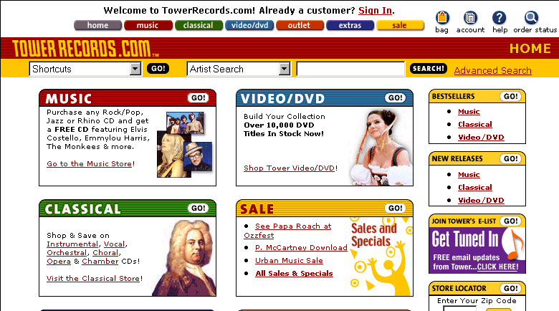
Figure 1: Home page. The test participants thought the page displayed well what was on the website.
Most of the test participants commented favorably on the home page, which is shown in Figure 1. They felt that it gave them a good idea of how many categories the store contained.
Three of the six test participants had problems finding their way back to the home page. They did not notice the Home button at the top of the page and clicked their way back using the Back button.
This is important because quite a few of the test participants returned to the home page whenever they were given a new task.

3.3. Navigation
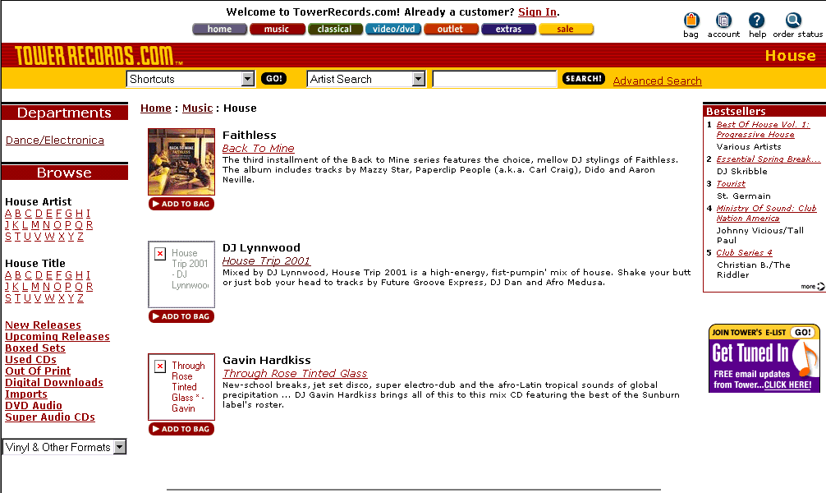
Figure 2: Dance/Electronica/House category page. None of the test participants who visited this page noticed the bestseller list to the right. During debriefing they commented that it looked too much like an ad.
All test participants used the left menus and entries at one point or another and none of them had any problems using them. See Figure 2.
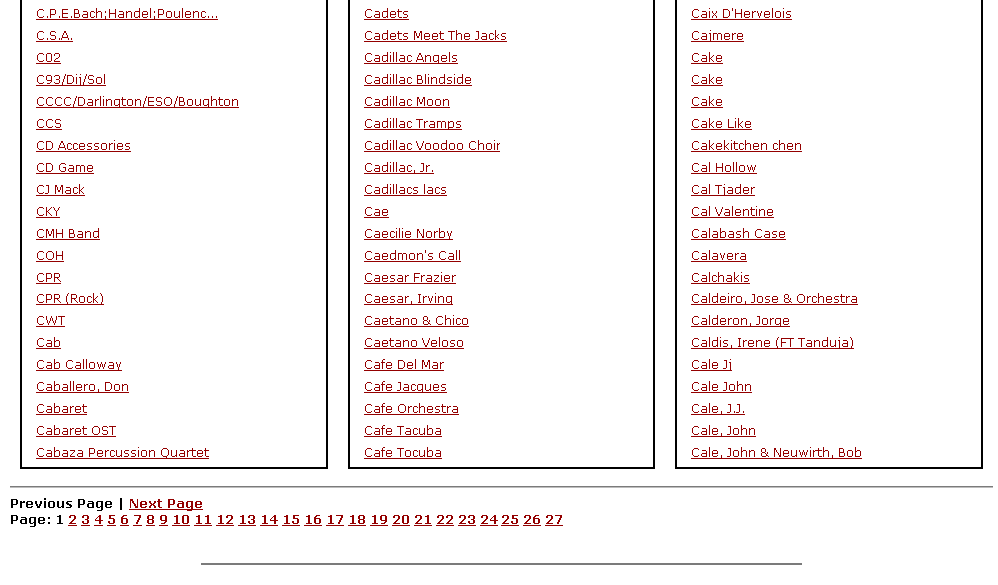
Figure 3: Alphabetical listing of artists. The test participants found it very difficult to navigate the listings efficiently.
The alphabetical listings shown in Figure 3 were not always helpful for the test participants.
One participant looked for the pop group “Creed” in the list of artists. He selected C and got a list of 27 pages 1 2 3 4 … 27 with no further indication of where to search for a particular artist as shown in Figure 3. He clicked 13 and got Chuck Higgins through Clapton, Eric & The Yardbirds. Then he clicked 25 and got a blank page. Although puzzled by this he clicked 20 and got Corrupted Ideals through Coward; Porter. Finally, he gave up with the comment
“It will take me forever to find Cr.”
Recommendations:
- Replace the page numbers with the first characters of the items that appear on each page, for example Ca-Cab, Cac-Car, Cas-Cav
- Clean up the list so it contains no links to empty pages.
None of the test participants seemed to notice the Bestsellers box in the right part of the House category page. Two participants referred to the box as “The advertising field to the right”. See Figure 1 and 2.
Recommendation:
- Place important information like this in sections of the pages where users look: the center, the left, and the top.
- Alternatively, place this information on a separate page and link to it from the center column with links like Bestsellers.

3.4. Search
All test participants immediately noticed the search box and intuitively knew both what it was for and how to use it.
Test facilitator’s comment: When the appearance of search matches the de facto standards – a visible search box and a button placed right next to the field – visibility problems rarely occur.
The search facility was tolerant and accepted misspellings. One participant entered “Pokenon” and was correctly presented with results for “Pokemon”, another entered “Anne Sofie Mutter” and was correctly shown results for “Anne-Sophie Mutter”.
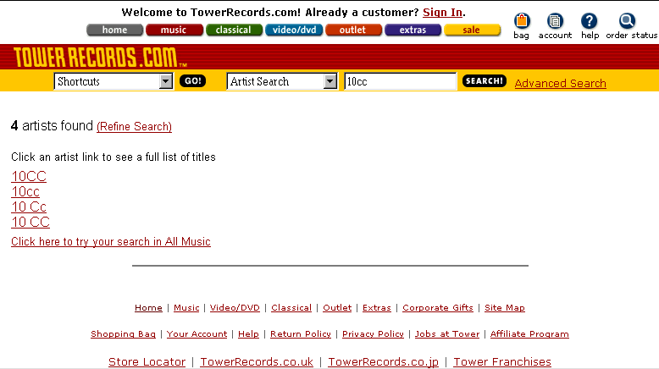
Figure 4: 10cc search result. The four links point to different lists of albums by the same band. The link 10 Cc leads to an empty page. None of the test participants could get a complete overview of the 10cc discography.
Test participants were confused by the consequences of numerous misspellings of artists’ names in Tower’s database.
One test participant searched for Destinys’s child (instead of the correct Destiny’s child). He got one hit: a single due to be released in June. It appears that the misspelled form existed in the database and that it blocked further tolerant search. Had he typed the name right he would have gotten 66 relevant results. If he had entered Destinys child the website would also have presented just one result – the same result as for Destinys’s child
Other test participants were confused when a search for Pokémon, which is the correct spelling, returned just one movie. Had they typed Pokemon they would have gotten two pages with 67 results.
When test participants searched for the rock group 10CC, the search engine returned the link results 10CC, 10cc, 10 Cc, and 10 CC as shown in Figure 4. When participants clicked the links they found that the content of each list was different. The database entries for 10cc appear to have been created by different people who do not agree on the correct spelling of the group’s name. Apparently, the search engine considers 10CC, 10cc, 10 Cc, and 10 CC to be four different groups. In addition, the link 10 Cc turned out to be empty. This did not delay the test participants significantly, but it did lead to negative comments about lack of quality assurance of the website.
Recommendation:
- Allocate more resources to quality assurance.
- Clean up the existing database entries so spelling is consistent.
The search engine was not helpful when a test participant’s query yielded a large number of results.
When test participants searched for the song title Homeward Bound they were given all 77 titles that contained the two words.
“There are way too many here. Most of them are not even the right ones.”
One test participant wanted Mozart’s Requiem with the Berliner Philharmonics and Herbert von Karajan. He searched for Requiem on the Classical home page but kept getting too many results on his searches (200-500) and eventually gave up.
A Refine Search option was available on the search result page, but our test participants either didn’t notice it or didn’t understand what it meant.
Recommendation: A search that yields a large number of results should produce a page that offers the following options:
- A link to the most popular product.
- A link to the product that is currently being promoted by the store.
- An explanation of the “Refine Search” function with a link to the Refine Search page.
- A link to the full, ordinary search result page.
None of the test participants had any success using Advanced Search. The products they found were all found using simple search and they quickly gave up using Advanced Search.
Test participants who used Advanced Search only received empty search results, and they received no help as to why the results were empty.
Recommendations:
- Assist users by explaining how Advanced Search is best used and by giving them descriptive examples.
- Whenever users run into problems with Advanced Search, strongly recommend that they leave advanced search and use simple search instead.
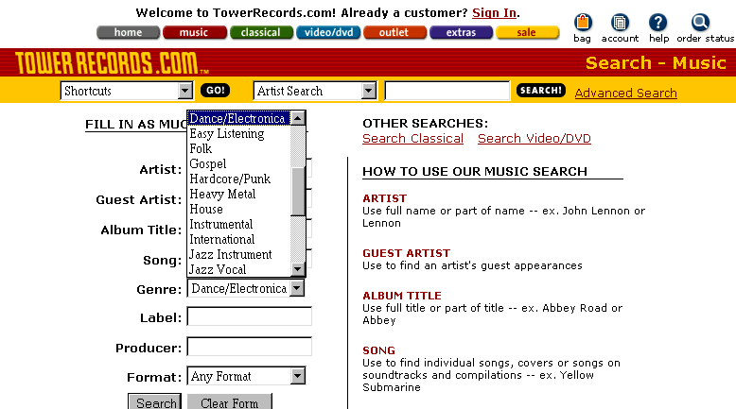
Figure 5: Advanced search. All test participants tried to select House under Genre and start advanced search with only this search criterion. The search result was blank.
In general, test participants were not very successful using advanced search. They only managed to get useful results with simple search.
All test participants tried to search for a certain genre, for example House, without filling in anything else in the advanced search fields as shown in Figure 5 above. The website responded Sorry, nothing was found matching
Recommendation: When users search only for a genre, direct them to the category page for the genre.
The default search scope caused problems. Three of the six test participants who searched for Anne-Sophie Mutter did not notice that the default search scope was Rock/Pop. Anne-Sophie Mutter has one title in the Rock/Pop section while she has at least 159 titles in the Classical section. Unfortunately, there is no indication in the Rock/Pop result that there are many more results in the Classical section and test participants did not notice or understand the implications of the Genre: Rock/Pop feedback at the top of the results page.
It was clearly more confusing for test participants to get a few results than to get no results at all. When the website showed only a few titles as a search result test participants would sometimes accept this as the full result whereas they would always search again using other methods when they got an empty search result.
Recommendations:
- Remove the search scope in simple search.
- Provide a visible link if results exist for other scopes than the one that is currently selected.

3.5. Product Information
Several test participants appreciated that product information included relase dates as shown in Figure 6.
“It makes it so much easier to see if it’s a remix or the original album.”
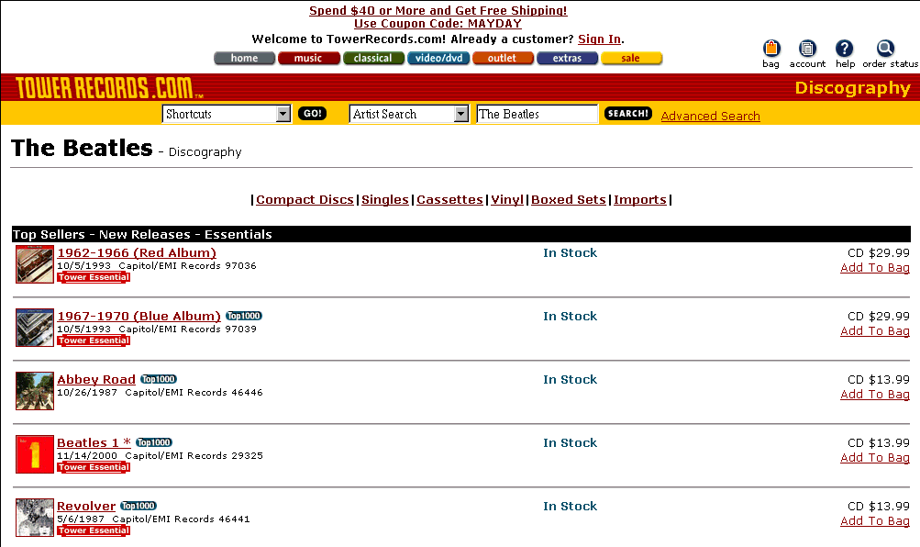
Figure 6: Thumbnail cover pictures. The test participants were pleased with the cover pictures and concentrated mainly on the albums whose covers were shown.
All test participants appreciated that they could see covers of the albums, videos or DVDs in the product listings, as shown in Figure 6.
“This is the right way to find them. Oftentimes I cannot remember the name of the album, but I can always remember the cover.”
Some of the test participants were annoyed that not all covers were displayed.
“Unless I recognize the one I want immediately, the cover pictures do not help me since I cannot compare them.”
Test facilitator’s comment: Unless test participants were looking for a specific album, they directed their attention primarily towards the albums that had the covers displayed. Only the cover convinced them that they had found the right album.
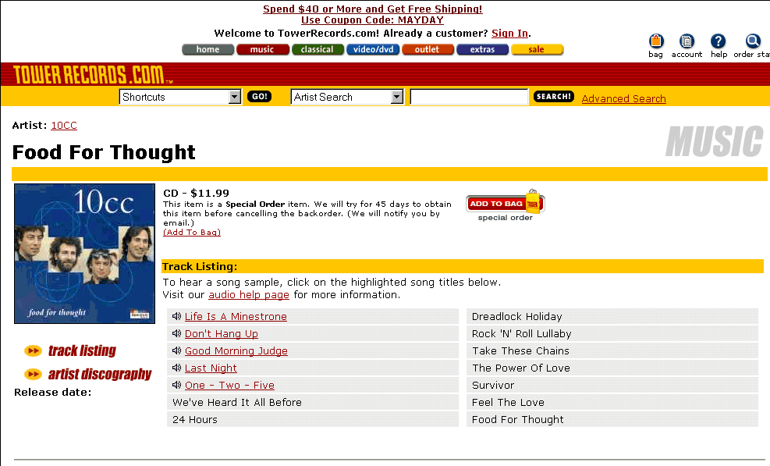
Figure 7: Track Listing. Test participants found the listing of tracks on individual albums informative. They also appreciated that they could hear samples of some of the tracks.
All test participants found it helpful that they could listen to 30-second samples of the tracks on the individual albums. See Figure 7.
“This is helpful. There are very few albums I would buy without listening to them first.”
Four of the six participants commented that it was annoying that they could not hear samples of music from all albums.
“When they finally have something I am interested in then why can’t I hear it?”
One participant noted that the newest albums seemed to be the ones you could not hear.
Test facilitator’s comment: None of the test participants looked for an explanation. We have not been able to find one.
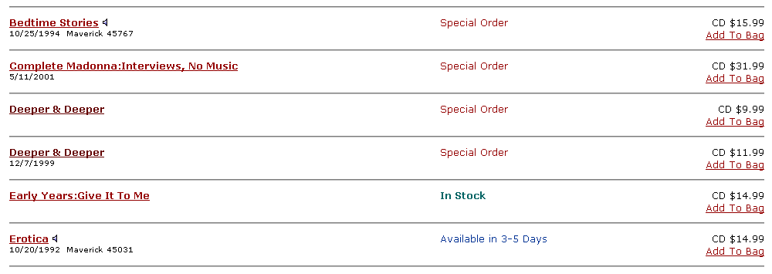
Figure 8: Missing product information. None of the test participants understood why one Deeper & Deeper album was more expensive than the other.
All test participants found it confusing that there were several different prices for what seemed to be the same album as shown in Figure 8. They could not find explanations for the difference in price in any of the product descriptions. As a result all of them decided not to buy any of the albums.
Test facilitator’s comment: A customer-focused sales clerk would have explained the difference between the CDs and maybe have recommended one over the other.
Figure 9 and 10: Missing product information. Test participants found that there was insufficient product information to efficiently compare different versions of the same albums.
Three of the test participants misread the text accompanying Special order items and thought that the 45 days was the delivery time for the items. They often dismissed the album for that reason. See Figure 10.
Recommendation: Rephrase the text. Emphasize that Tower will try to obtain the product for the customer. De-emphasize the length of the period.

3.6. Checkout
We encouraged all test participants to complete the purchase of the product that they had defined themselves. For all tasks defined by DialogDesign we asked the test participants to continue until they had filled in the information on the Payment page. At this point the facilitator terminated the task.
All test participants succeeded in putting the items they wanted to buy into their shopping bag by clicking Add to Bag as shown in Figure 6 and 8.
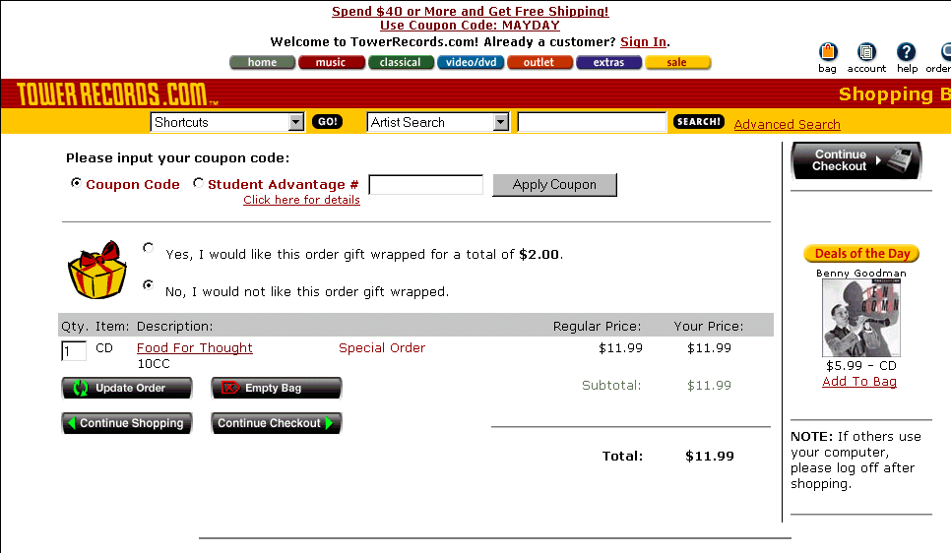
Figure 11: Shopping Bag. Some of the test participants had problems removing an item from their shopping bag.
Four of the test participants had problems removing an item from the shopping bag when the bag contained more than one item. See Figure 11. They were not aware that they could remove an item by changing the quantity in the left field to zero and clicking the Update order button. After considering the problem for a while they clicked Empty Bag and started over.
Recommendation: Add the link Remove to each item in the shopping bag.
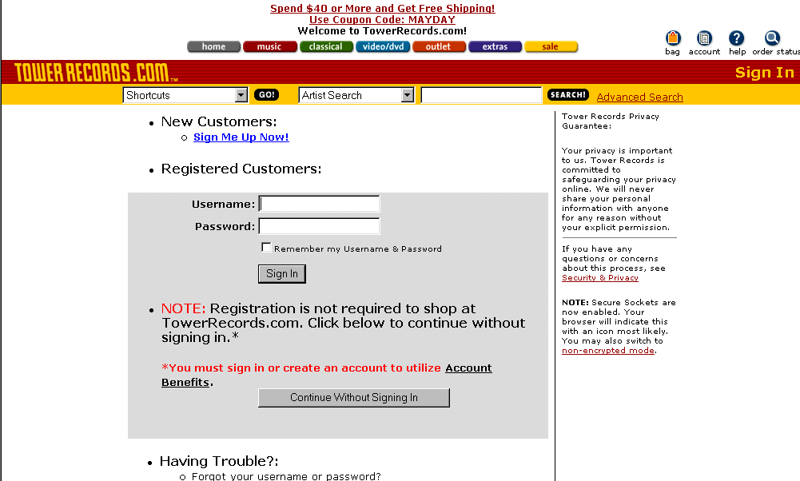
Figure 12: Sign In. The test participants were pleased that they did not have to sign up as customers to buy items in the store.
All test participants commented favorably on the fact that they did not have to register to buy goods at the site. See Figure 12.
“I don’t want to tell them all about me to buy a record, so this is fine.”
None of the test participants chose to register on the website.
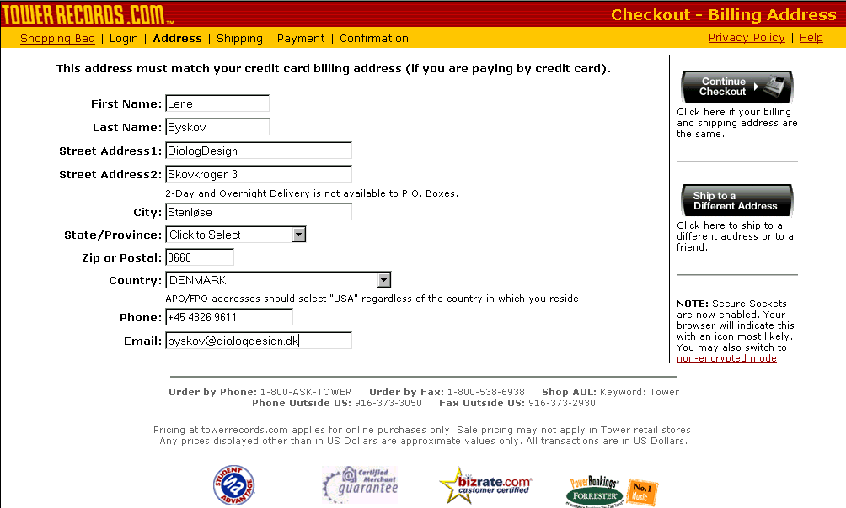
Figure 13: Address. Two of the test participants had minor problems with placing the zip code. They also wondered whether they should write their address in English or Danish.
Three of the test participants were in doubt as to where they should enter their Danish zip code and what they should do about State/Province. See Figure 13. All of them managed to fill in the address correctly, however.
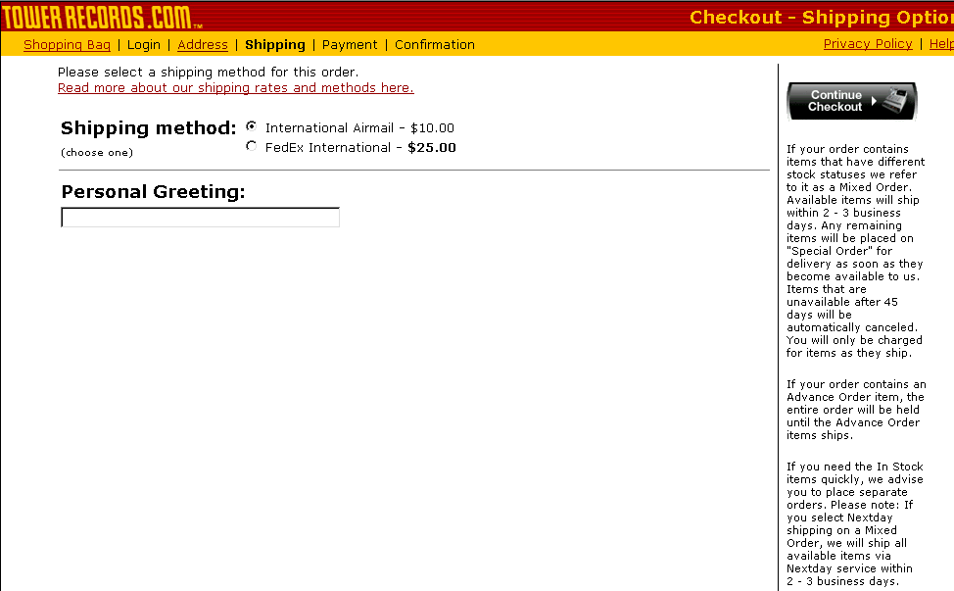
Figure 14: Shipping.
The test participants had varying interpretations of the purpose of Personal Greeting. See Figure 14.
“Why would I write a personal greeting to myself? This doesn’t make sense.”
Recommendation: One test participant suggested that Personal Greeting should be displayed only if the customer had selected Ship to a Different Address on the previous page.
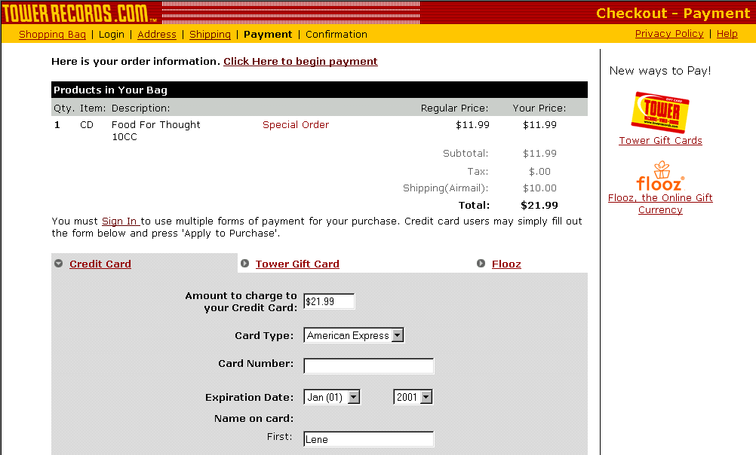
Figure 15: Payment. Test participants considered the overview of the total costs helpful. Filling in credit card information caused problems for some of the test participants.
The test participants were happy with the overview provided by the website of the total cost including shipping shown in Figure 15.
Test facilitator’s comment: Unlike participants in other tests we have conducted, none of these participants complained that the shipping cost appeared rather late.
Some of the test participants were unsure how they should write the credit card numbers in the Card Number field. They were pleased to find that the website was error tolerant: Credit card numbers were accepted both with and without spaces.

3.7. International Issues
None of the Danish test participants experienced problems working with the website even though it was in English. None of the participants felt inhibited by phrases that were unfamiliar to them.
All test participants expected that the amount specified under Total was the amount that they would have to pay. See Figure 15. For international customers, however, local taxes and duty may be added. This amount varies from country to country.
Recommendation: Warn international customers that additional costs may be added to the cost displayed under Payment. A link to further information about such costs would be helpful.
All test participants pondered for a moment what Coupon code was and if they were eligible for a rebate. See Figure 11. The test participants who were students checked the student reduction information but all of them quickly returned to the checkout process.
Recommendation: It needs to be clear from the detailed information accessible from the Shopping Bag page that the Student Advantage only applies to American students.
Three of the test participants did not notice Tower’s warning that all videos were in NTSC-format. They would have bought them without realizing that the videos might be useless because many European video players will not play an NTSC-format video.
Recommendation: Make this information more prominent on the Video/DVD page, or add it to a page that is directed specifically towards international customers as described above.
The three test participants who saw the information about the video format all commented that it was annoying that they had to select a movie before they were told that it was in a format that they could not use.

Appendix A. Approach
The test has been carried out with six Danes who all belong to the target group for the website. The profiles of the test participants appear in section A.3. Test participants were tested one by one.
A Danish usability professional acted as test facilitator. All tests were conducted in Danish in a rented meeting room in the center of Copenhagen. Each test took between 1 and 1½ hour.
A DialogDesign usability test consists of three phases: Interview, Solving test tasks, and Debriefing. In this test the phases contained the following steps:
Interview: Test participants signed agreements to the fact that they were guaranteed anonymity and that DialogDesign was free to use their comments and suggestions in the test report. Test participants were then interviewed about their expectations to the website before they saw it.
Solving test tasks: Test participants were asked to carry out tasks using the website.
Each test participant defined the first task. These tasks are included as appendix C. DialogDesign defined the remaining tasks. These tasks are included in the usability test script in appendix A.
The facilitator contacted the test participants on the day before the test and asked them to think of music they would want to buy using the internet. The facilitator did not reveal what specific website they would be testing. At the test the participants were asked to use Tower’s website to buy what they had planned. All test participants were told that DialogDesign would reimburse them for expenses up to 45 USD. If they chose not buy anything on the website, they would get a gift certificate of 35 USD in appreciation of their time spent.
This approach ensured that test participants were solving realistic tasks for which they were highly motivated.
Test participants were asked to think aloud and to comment on the website while they were carrying out their tasks.
Debriefing: Test participants were asked to fill in a questionnaire while thinking aloud. We were particularly interested in the verbal comments they made while filling in the questionnaire. In addition, test participants were debriefed about their general impression of the website. The questionnaire and the debriefing questions are included in the usability test script in appendix A.

A.1. Discussion of Method
The basis for this usability test is the recognized “think aloud” method. This method is described in several generally recognized books within the usability field, for example:
- Brugervenligt webdesign (User-friendly web design) by Rolf Molich (available in Danish only, published by Ingeniøren|Bøger 2000).
- Usability Engineering by Jakob Nielsen (Academic Press 1993, see also www.useit.com).

A.2. Equipment
The equipment used for this test was a laptop with a 600 MHz processor and a 15” monitor set to a resolution of 800 x 600 for five test participants and 1024 x 768 for one test participant. Microsoft Internet Explorer 5 (version 5.00.2614.3500IC Danish) was used.
The computer was set up to communicate with the website through a commercial Danish Internet provider (TDC) using a 56K modem. The true speed was approximately 34K. The transmission speed was thus as close as possible to what a typical user would experience.

A.3. Test Participant Profiles
The tests were carried out with test participants who fulfilled the following requirements:
- Between 18 and 40 years old.
- Had already bought on the Internet or were willing to do so.
- Somewhat experienced to experienced Internet users.
The number of men and women in the group were equal.

Participant | Gender | Age | Title | Internet experience* | Shopped on the Internet before? | Familiar with Tower website? | Knows Tower Record Stores?
1 | Male | 39 | Assistant educator | Experienced | No | No | Yes
2 | Male | 40 | Senior scientific project manager in medical industry | Experienced | Yes | No | Yes
3 | Female | 29 | English translator | Somewhat experienced | No | No | No
4 | Male | 20 | Student at the Copenhagen School of Business | Somewhat experienced | No | No | No
5 | Female | 28 | Law student | Somewhat experienced | No | No | No
6 | Female | 38 | Business software developer | Experienced | Yes | No | Yes
* Internet experience was classified by the test participant according to these groupings:
- None (e.g. has never heard of it or only read about it)
- Bystander (e.g. has watched other persons use the internet)
- Beginner (e.g. has used it once or twice)
- Somewhat experienced (uses it regularly)
- Experienced (uses search facilities without problems)
- Very experienced (has developed websites, knows HTML)

Appendix B. Usability Test Script

B.1. Before test
- Clear computer cache and cookie list.
- Start browser – go to www.TowerRecords.com – minimize browser.

Test facilitator:
Test facilitator is neutral – I have not participated in the development of this website. Please provide as many comments as you possibly can.
This is not an examination – in any case not of you.
If anyone is up for exam it is the members of the website project team.
In other words: You can do nothing wrong during this test.
I will answer only very few questions from you – Sorry! But please ask questions anyway. The questions may give me important clues. I may ask questions you will find odd. The reason is that we want to understand how you interpret this website.
Please think aloud during the test. This will enable me to follow your thoughts. I am interested in any and all comments. Positive as well as negative.

B.2. Pre test interview
- What did you decide to buy?
What the test participants intend to buy will later be compared to what they actually buy. The test facilitator writes down information about the desired product.
- Have you ever visited websites that sell music? - Which?
Have you ever bought music over the Internet? If yes, what was your experience?
Have you ever bought other things over the Internet?
- What are your expectations to a website that sells music?
- What facilities would you expect to find?
What would be particularly great for you to be able to do on a site that sells music?
- What facilities would you not want on a site of this type?

B.3. Test tasks
- Please buy the music you decided before coming here.
(Test of actual use with a highly motivated user.
Remember to ask when the test participant expects to receive the item(s) ordered!)
- On June 3 your nephew turns 5. He loves Pokémon and can spend hours playing with it, but so far he only has cards. You want to give him a videotape. Find and order a gift you can bring for your nephew. You have DKK 200.
(Test of the website’s success in advising customers - target item: videotape. When Tower asks for credit card information the test facilitator breaks off this task.)
- You have now received the item for you nephew, but it turns out that there is a nasty crack in the video cover. The cover of the Pokémon movie is very important for your nephew. What do you do?
(Test customer service information.)
- A girlfriend of yours is a big fan of Anne Sofie Mutter and she has all her recordings up to 1995. You want to send her a CD she does not already have. Can you get that here?
(Test of the website’s ability to provide information and limited item lists. When checkout starts the test facilitator breaks off this task.)
- You are going to a party for the 16-year-old of the family. You know that he likes “House”, but not what, and you want to buy him what is most popular right now.
(Test of placement of information about the most wanted albums. When checkout starts the test facilitator breaks off this task.)
- You have three of 10cc’s albums and would like to know how many they have actually made.
(Test of using the website for information retrieval.)
- You have just heard the song “Homeward Bound” in an particularly good recording on the radio. Unfortunately you did not hear who recorded it but you know that you will recognize it if you hear it again. Can the website assist you?
(Test of playing back music.)
- You ordered a CD from Tower yesterday and now you see it at half price at your local record store. What do you do?
(Test customer service information.)

After 50 minutes the test facilitator terminates the test regardless of the number of test tasks completed.
Individual tasks can also be interrupted if the test participant cannot advance with the task or if the test facilitator finds that no new information would come of continuing with the task.

B.4. Interview after test
- You have now worked with the Tower website for about an hour. Do you find that the content is relevant for you?
- Is there anything missing?
- Do you have any comments on the search functionality?
- If the test participant has visited other websites that sell music: How does the Tower website compare?
- Do you have any comments regarding the graphics on the website?
- Please mention one or two things about the website that are particularly in need of improvement.
- Please mention one or two things that you found particularly good about the website.
- Will you use this website in the future?
- May I contact you in 10 days to hear if you received the products you ordered and how the delivery process went?
The number of days before the test facilitator contacts the test participant depends on the expectations of the participant as to when the goods will be delivered and so may vary from one participant to another.
We run several tests and we get many good comments and suggestions from the test participants. It is particularly interesting to us if several test participants run into the same problem or provide similar comments.
- Would you participate in a test like this some other time?

Hand over gift
(Only if the test participant did not succeed in buying anything or decided not to buy anything on the website.)

Appendix C. Test Task Results
The chart below lists all test tasks and all test participants. Each entry indicates how successful the test participant was in solving that particular task.
Solved without problems.
Solved with minor problems.
Solved, but serious problems arose which delayed the test participant significantly.
The test participant could not solve the task or reached a result which was significantly different from the desired result.
(blank) The task was skipped for lack of time.

 | Participant 1 | Participant 2 | Participant 3 | Participant 4 | Participant 5 | Participant 6
User-defined *
Buy Pokémon video
Damaged product
Buy classical
Recommend modern
Discography
Song search and playback
Return policy
* The full task descriptions appear in appendix B.3 and D.
Three of the test tasks produced an unusually high number of disasters (indicated by ), namely tasks 1, 4 and 5. These tasks are explained in more detail below:

Test Task 1, "User-defined"
We considered this task a disaster if
- The test participant showed a willingness to buy something but did not succeed in finding the desired items even though they were available on the website.
- The test participant found the desired item but did not succeed in completing the purchase.
- The test participant reached a result that was significantly different from the desired result.
Only one test participant (#6) bought anything on the site even though the other five originally had the intention to do so.

Test Task 4, "Buy classical"
The large number of serious difficulties with this task stem almost solely from the fact that when the test participants searched for Anne-Sophie Mutter, they were given only one album to choose from because the default search scope is the “Rock/Pop” section. Most of the recordings with Anne-Sophie Mutter are in the “Classical” section. If they selected the “Rock/Pop” album without looking for other albums, we considered the result a disaster since the test participants had reached a result without noticing the many relevant alternatives.

Test Task 5, "Recommend modern"
As described in section 3.3, none of the test participants noticed the “Bestseller” section under House, and so they just selected the first available album. Only one of the test participants knew the band in question whereas the others selected the album blindly, which we consider a disaster.

Appendix D. User-defined Test Tasks
Below you find a list of the tasks the test participants brought to the test:

Test participant one:
“I'll be looking for something by ACDC or Montrose.”

Test participant two:
“I know exactly what I am getting: Live at Montreux by Tito Puente, but I doubt if I can get it. If I don't find it, I'll be looking for something by Valdemar Rasmussen, Jacques Loussier, or Gitaro.”

Test participant three:
“I'm not sure what I'm looking for. I prefer rock and pop, and I think I will just let myself be inspired as I go along.”

Test participant four:
“I am looking for Black & Blue; Back Street Boys or Destiny's Child. - Maybe something with Mauro Picotto.”

Test participant five:
“I want to buy an album that has Something to remember by Madonna. If I don't find that, I'll look for an album that has The boatman's call or No more shall we part by Nick Cave & Bad Seeds.”

Test participant six:
“I want to buy Mozart's Requiem and a Take That album with a specific track. If I don't find those, I will just look for something from the seventies”

